**Write your name and student ID# on EVERY PAGE of your exam**

**MCB 141 Midterm I Feb. 14, 2012**

**Question #1 / 28 pts**

**Question #2 / 27 pts**

**Question #3 / 25 pts**

**Question #4 / 20 pts**

**BONUS / 1 pt**

**TOTAL / 100 pts [plus 1 possible bonus pt]**

**Exam is closed book, closed notebook**

**NO CELL PHONES or other electronic devices**

**Exams must be turned in by 12:30 PM**

**All answers must be written in ink.**

**If you need extra space, write on the back of the page, but clearly indicate this on the front page of the question**

**Regrade policy: Turn in your entire exam to Sofia and include a written explanation as to why you think you deserve additional credit.**

**Question #1** [28 points]

We have discussed the pathway that establishes the initial dorsal/ventral polarity of the fly embryo (see below).

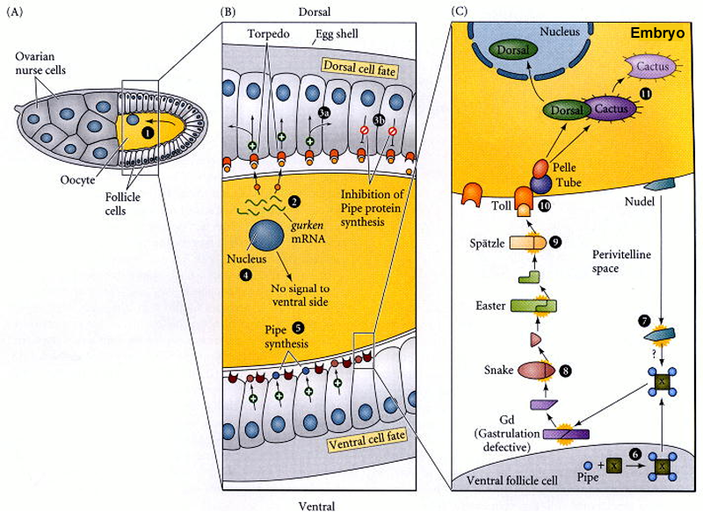

Predicted the phenotype (dorsalized, ventralized, or normal) of embryos produced by females of the following genotypes (assume all “**–**” alleles are complete lack of function alleles.). No explanation is needed for 1a-e, but do provide a brief explanation of your answers for 1f-h.

**1a)** gurken**–** / gurken**–** [1 pt; no explanation needed]

**1b)** easter**–** / easter**–** [1 pt; no explanation needed]

**1c)** torpedo**–** / torpedo**–** [1 pt; no explanation needed]

**1d)** gurken**–** / gurken**–** ; easter**–**, / easter**–** [2 pts; no explanation needed]

**1e)** easter**–** / easter**–** ; cactus**–** / cactus**–** [2 pts; no explanation needed]

You discover a new, dominant allele of torpedo which you call torpedo**D**. The torpedo protein produced by the torpedo**D** allele acts as though it is always bound by gurken protein (even when gurken protein is absent).

**1f)** Assume a female fly is:

torpedo**D** / torpedo**+** ; gurken**–** / gurken**–** ; cactus**–** / cactus**–**

Predict the phenotype of the resulting embryos [1 pt]

AND of the phenotype of the eggshells (dorsalized, ventralized, or normal) [1 pt]

Briefly explain your answer. [5 pts]

**1h)** You use pole cell transplantation to create a female that has the following genotypes:

germline: torpedo**D** / torpedo**+** ; gurken**–** / gurken**–** ; easter**–** / easter**–**

follicle cells: torpedo**+** / torpedo**+** ; gurken**+** / gurken**+** ; easter**+** / easter**+**

Predict the phenotype of the resulting embryos [1 pt]

AND of the phenotype of the eggshells (dorsalized, ventralized, or normal) [1 pt]

Briefly explain your answer. [6 pts]

**1i)** You want to experimentally confirm the relative order of the action of snake, easter, and spatzle in the DV pathway (see the figure of the D/V pathway at the start of this question). You have available to you females that are homozygous mutant for easter, other females that are homozygous mutant for snake, and a third set of females that are homozygous mutant for spatzle. You also have some "pre-cleaved" easter protein in a purified form which you can inject into the perivitelline space (fluid space between the chorion produced by the follicel cells and the membrane of the embryo) of newly laid eggs (just after fertilization, but before the first nuclear division cycle). Describe the experiment that you would do, and the expected results you would see that would confirm the relative order of the cleavage of snake, easter, and spatzle. [Hint: when you inject pre-cleaved easter into the perivitelline space of an embryo laid by a wild-type mother, the injected material diffuses into all the space around the circumference of the egg, and the resulting embryo is ventralized). [6 pts]

**Question #2** [27 points]

You inject bicoid mRNA into the posterior end of newly laid wild-type eggs (the injected mRNA is about the same amount as would normally be found at the anterior end, and this injected mRNA remains localized to a small region at the posterior). Shown below and to the left are graphs showing the distribution of several mRNAs and protein in uninjected embryos.

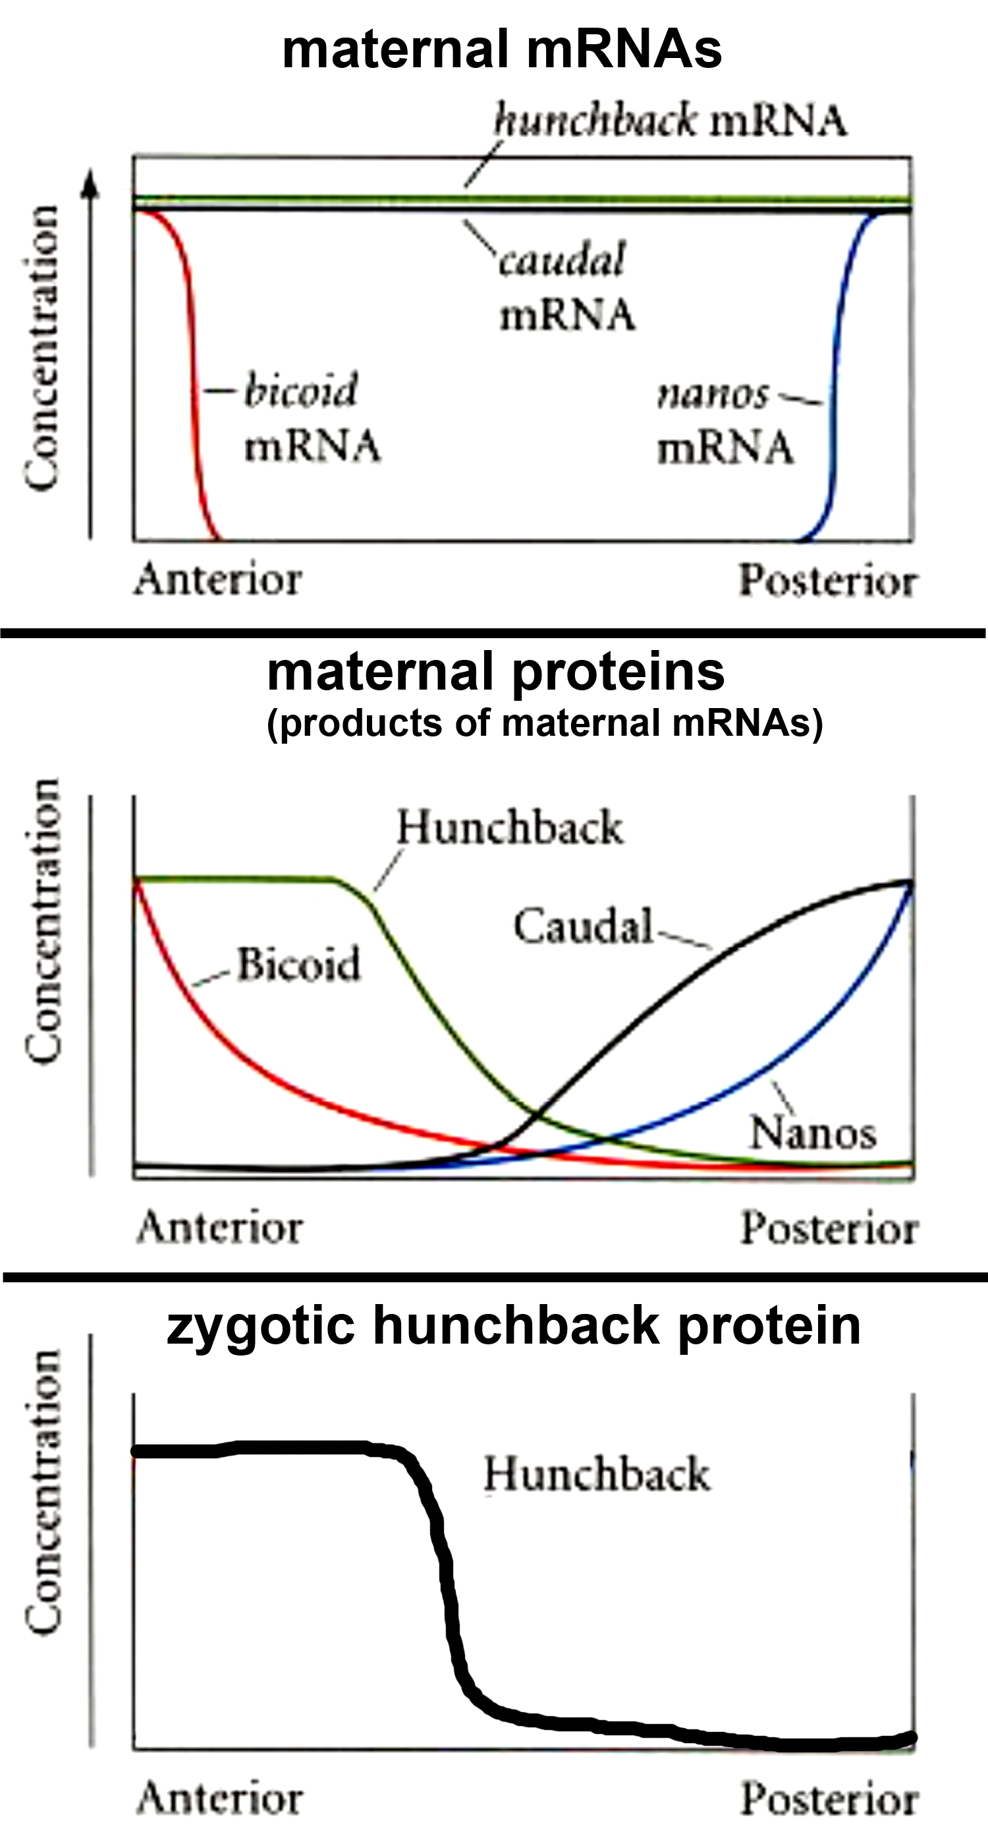**2a)** Draw (as a graph) the expected distribution of **bicoid protein** in these embryos (no explanation needed). [1 pt]

**2b)** Draw (as a graph) the expected distribution of **nanos protein** in these embryos (no explanation needed). [1 pt]

**2c)** Draw (as a graph) the expected distribution of **maternal caudal mRNA** in these embryos (no explanation needed). [1 pt]

**2d)** Draw (as a graph) the expected distribution of **maternal caudal protein** in these embryos (no explanation needed). (Note: in wild-type embryos there is

[1 pt] also a posterior stripe domain of

zygotic hunchback expression,

but you can ignore this domain when

answering the questions here).

**2e)** Draw (as a graph) the expected distribution of **maternal hunchback protein** in these embryos. Briefly explain your answer. [4 pts]

**2f)** Draw (as a graph) the expected distribution of **zygotic hunchback protein** in these embryos. Briefly explain your answer. (Note: you can assume that nanos protein has no effect on the translation of zygotic hunchback mRNA as nanos protein has decayed by this time.) [4 pts]

**2g)** You examine the expression of wingless mRNA, engrailed mRNA, and engrailed protein and see the following patterns in a wild-type embryo (expression indicated by grey color filling cytoplasm or nucleus; about 2.5 segments are shown in the diagram).

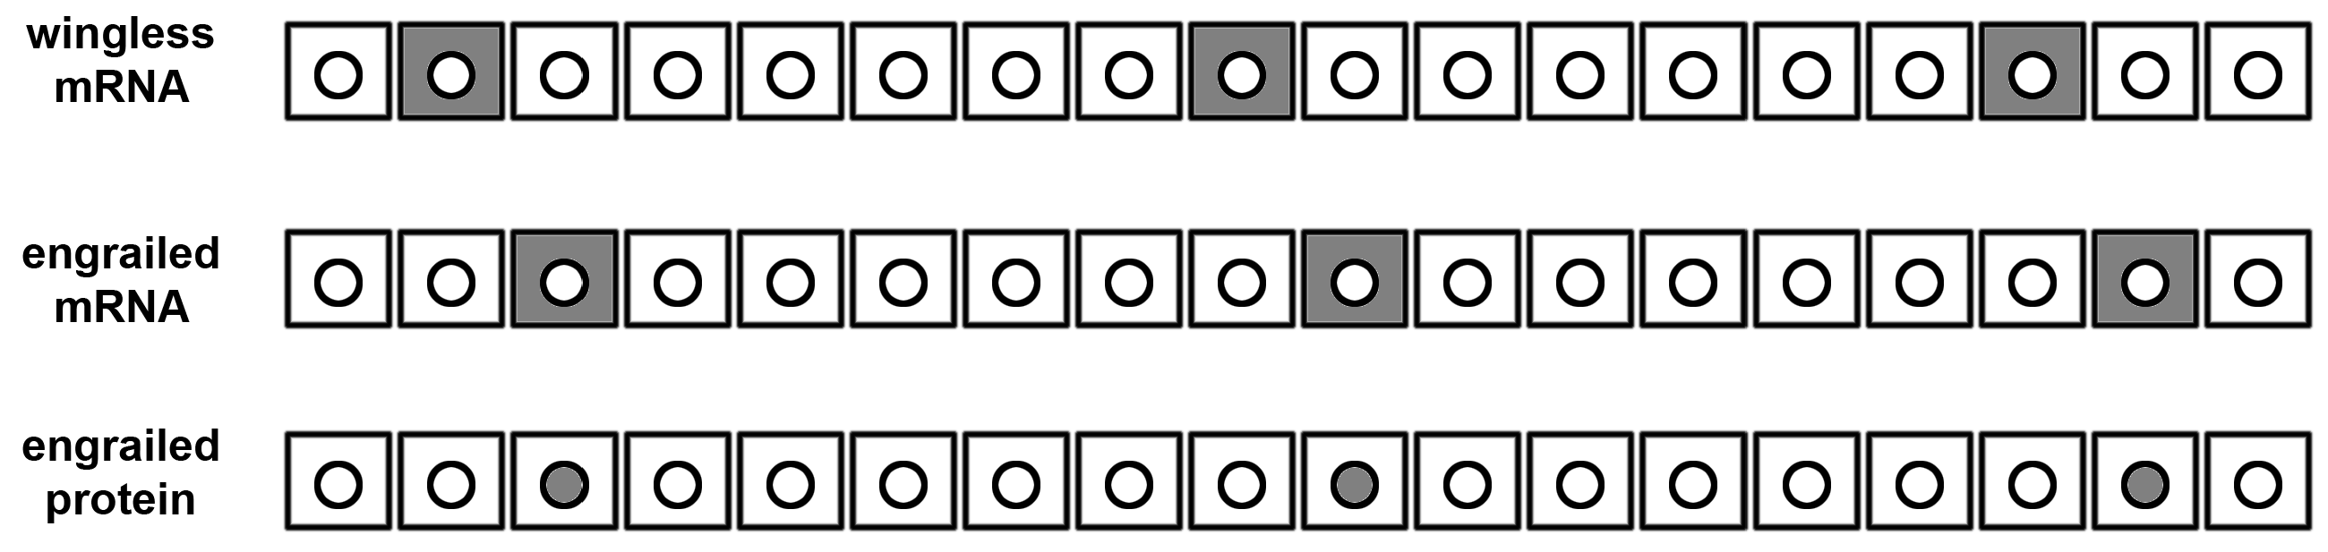

You then examine the patterns in embryos that are homozygous for a mutant allele of engrailed called en**pn**. This engrailed allele expresses engrailed mRNA in the normal pattern, but there is a single altered nucleotide in the coding region (resulting in a single amino acid change) that causes the resulting engrailed protein to be completely non-functional.

You see that en**pn** / en**pn** embryos that are at the end of the blastoderm stage and just starting to gastrulate and germband extend (3-4 hrs old) show wild-type patterns of expression of both wingless and engrailed mRNAs and engrailed protein. Why are they all normal at first? [5 pts]

Slightly older embryos (5 hrs old) show an absence of wingless mRNA. Even slightly older embryos (6 hrs old) show an absence of both wingless and engrailed mRNA. Finally, the oldest embryos (7 hrs old) show an absence of both wingless and engrailed mRNA as well as engrailed protein. Explain these observations regarding the order in which these mRNAs and protein disappear in en**pn** / en**pn** embryos. [10 pts]

**Question #3** [25 points]

Ubx in Artemia (brine shrimp) is expressed in T1 and posterior, while Ubx in Parhyale (beach hopper) is expressed in T2 and posterior . Outline an experiment to determine if the changes that cause the difference in expression between these two species are "cis" or "trans" (Note: for the sake of simplicity, assume you can directly assay any injected embryos, and you don't have to wait until the next generation). Describe the expected observations if the change is "cis" and describe the expected observations if the change is "trans".

Continue answer to question #3 on this page if additional space is required:

**Question #4** [20 points] + [1 BONUS point]

In humans maternal effect mutations are rare, but you read about a remarkable example of a recessive maternal effect mutation that increases lifespan. The gene is called "methusalah". Most women contain two copies of the wild-type allele (met**+**/met**+**) and their children live the average lifespan expected of most people (80 years). However, women who are met**l**/met**l** have children who live on average to be 120 years old. You also read that the same gene also causes a recessive zygotic phenotype. Men and women who are homozygous for the met**l** allele have hair that turns green at the age of 25.

You are an executive at the world's most popular social media company (F**e**ok) and in charge of hiring a person to serve ice cream to employees in the new Menlo Park headquarters. You interview two men, call them Bill and Ted, who are cousins - their mothers are sisters. They are both seniors at UC Berkeley who are going to graduate with a 4.0 GPA in Computer Science and you decide they are both equally qualified for the job. You hack into their medical records and discover the following information about their grandparents on their mothers' side –this grandmother was met**+**/met**l** and this grandfather was met**+**/met**l**. You ask Bill and Ted to show you recent photos of their parents. You see that Bill's mom has green hair and Bill's dad has brown hair. Ted's mom has brown hair and Ted's dad has green hair.

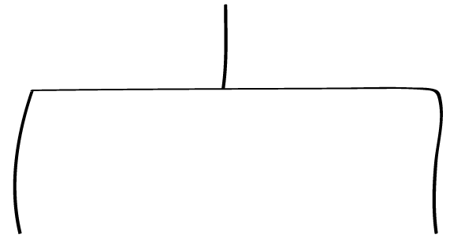 Bill and Ted's grandmother X Bill and Ted's grandfather

met**+**/met**l** met**+**/met**l**

Bill's dad X Bill's mom Ted's mom X Ted's dad

 | |

| |

| |

Bill Ted

You anticipate that either Bill or Ted would retire at age 65, and after retirement, either would cost the company about $20,000 per year in medical and retirement benefits from the time they retire to the time they die. You conclude that you could save the company $800,000 by hiring one over the other.

Who do you hire? [3 pts]

Explain your reasoning. [17 pts]

[BONUS; 1 pt] You also tell the person you hire that he may soon have green hair. What is the probability that this person will have green hair at the age of 25? Provide a brief explanation.