Question Points Score

Total for Final: 200 ___________
1 | 13
2 | 20
3 | 9
4 | 15
5 | 9
6 | 28
7 | 28
8 | 26
9 | 17
10 | 8
11 | 9
12 | 18
 | 200

Question 1 ( points)

Question 4. (15 points)

Question 5. (9 points)

Question 6

6a ( points) Where do muscle precursor cells form? Draw a cross section through a chick embryo at a stage before neural tube closure and after neural tube closure indicating where they will be/are formed.

6b (2 points) Name one molecular signal that contributes to formation of the muscle precursor and indicate on the diagram above where it comes from and which population it acts upon..

6c (6 points) How would you test whether there is a contribution of neural crest cells to any of the muscles in the mouse. Provide a specific example if you can. Give an example of an advantage of the method you propose, and a disadvantage.

Question 6f (6 points) Provide another six examples of neural crest derivatives.
Question 7
7a (6 points) How would you make a mouse chimera where you could test the effect of the manipulations below.

Let’s assume you can make enough specimens to find the potentially informative example of the chimera below, where the hollow shapes are wild type, and the grey zone has the genotypes below Indicate the zones of expression of the following genes:
Nkx2.2, Olig2, Irx3, Pax3

b) Grey is Shh-/- c) Grey is Patched-/- d) Grey is Smo -/-
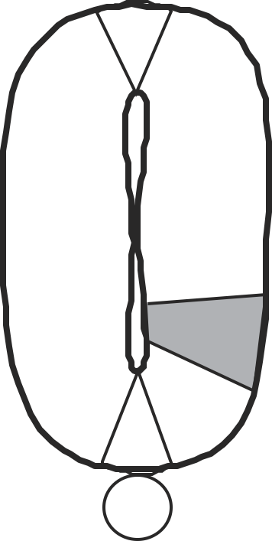

Question 8

8a ( 3 points) Let’s suppose you were starting to try to make induced pluripotent stem cells, back before Yamanaka showed it was possible, and before you knew what the “fantastic four” genes were that could be used to reprogram fibroblasts to become stem cells. On the other hand you do know everything about the expression of genes in the inner cell mass of the mouse embryo.

How would you set up a selection for genes that could induce pluripotency?

8b (3 points) What tool would you use to introduce genes into these cells?

8c (4 points) Let’s suppose your scheme worked, and you found that a population of induced cells contained a mixture of 36 genes that were introduced. How would you tell how many of these are important?

8d (4 points) What kinds of genes would you expect to find that are crucial, name them if possible.

Question 9
Strong signals in the embryo usually evoke a feedback response, and in some cases there are both positive and negative feedback loops.
9a (6 points) Provide an example in the mouse embryo where positive feedback ensures that mesoderm is formed effectively. Draw out how the pathway causes this positive feedback.

9b. ( 4 points) If the first example worked too well, then the whole embryo would become endomesoderm. What mechanism ensures that mesoderm is not formed in excess?

9c ( 4 points) Provide another example of negative feedback that is important in development

Question 10

10a.(4 points) Joe Sarkozy makes a transgenic zebrafish where he hopes to have a good reporter for oscillating gene activity during somite formation. He makes a construct, driving GFP from the her1 promoter/enhancer. However, on looking at successful transcgenic fish, he sees that the entire somatic and presomitic mesoderm glows brightly, and it is difficult to make out the individual cells.

How would you modify the construct to make it more useful? Describe aspects of your designed construct that would improve its effectiveness.

10b (4 points) Bearing in mind that a somite is added every 20 minutes in the fish, draw out the pattern of expression of the reporter at two ten minute intervals.

10c ( )draw one of these time points again, but adding in where the endogenous her1 mRNA and Protein would be expressed.

Question 10d Suppose you place a bead soaked in the FGF inhibitor SU5402 onto one side of the notochord, in the presomitic mesoderm. The bead will release SU5402 over time to locally inhibit FGF signaling (i.e. it doesn’t reach the other side of the notochord). Draw out the predicted consequence of this manipulation on the pattern of somites.

Question 10e. Suppose you do the same experiment with a bead soaked in FGF. Draw out the predicted consequence

Question 11 (9 points) Provide ten examples where BMP signaling is used in development. What is the target tissue and what is the result?

Question 12
12a (2 points)

You have available two mouse strains. One is transgenic for a GFP transgene that its expressed in the wolffian duct and ureteric bud

The other is a Ret+/- strain.

Draw out the crosses you would do to examine whether Ret signaling is required for kidney formation

How would you determine what tissues require the presence of the Ret gene?
Question 13
Spina Bifida is a fairly common birth defect in human populations. Even after supplementation with folic acid, babies are born with such problems. If you were a human geneticist screening such babies for mutant alleles, what kinds of genes might you expect to find that are mutated? Provide an example, and explain how you would do an experiment in a frog embryo to show that the normal gene is required for efficient neural tube closure

How would you test if the gene is required cell-autonomously?

Question 14.
What descriptive experiments would you do that might suggest that the vertebrate hindbrain is intrinsically segmented? (no more than three)

What lineage tracing experiment would you do to test whether the hindbrain is intrinsically segmented. Draw out the results you would expect.

Draw out and explain what you expect to occur is you grafted a piece of rhombomere 2 into rhomombomere 3.

Let’s suppose you get a different result when you graft rhombomere 2 into rhombomere 4. Draw this and explain why you might get a different result. What further experiments might you do to see whether your prediction might be correct?

Question 15 ( points)
The hemichordate worm is in the same phylum as we are, so might be expected to share some developmental mechanisms. However, in contrast to us, the worm develops a distributed nerve net, with neurons distributed throughout the skin. In some ways this is more like neurogenesis in Drosophila than vertebrates. The hemichordate has a fairly simple genome, without the whole genome duplications that occurred on the vertebrate lineage, so let’s assume they have only one copy of any gene.
John Gerhart and his colleagues have developed a method to manipulate gene expression, by knockdown using RNA interference.
How would you test whether neurogenesis uses a similar mechanism to a conserved regulation of neurogenesis in vertebrates and invertebrates (specifically Drosophila)? Give some details on the expected mechanism, then how you would test it.

