Handout 1

Key terms:
Nuclear equivalence

Differential gene expression

ICM cell/ embryonic stem cell

Pluripotent

Induced pluripotent stem cell (iPS)

Transcription factor

Repressor

Enhancer

Ligand

Receptor

Kinase

The invariant genome (nuclear equivalence):
- Gurdon experiment (Nuclear transfer)
- How was the experiment set up?

- What are the hypotheses for how genes are differentially expressed?

- What was the conclusion from this experiment?

- iPS cells
- What are ICM cells?

- What are some of the characteristics of a stem cell?

- How can you reprogram a differentiated cell?

- How was it proven with iPS cells that there is an invariant genome?

Differential gene expression:
3. Different cells make different mRNAs, but they also make some that are the same. What could some of the similar mRNAs be?

4. You do an experiment (called an in situ hybridization) that shows you, in purple, where a particular gene is expressed in the sea squirt embryo:
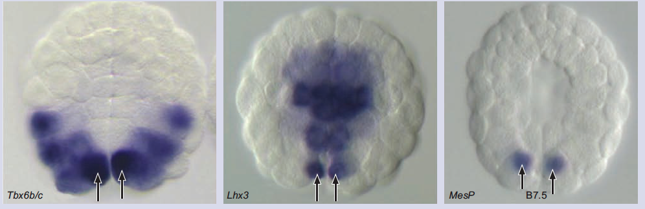
Both Lhx3 and Tbx6 have distinct gene expression patterns, but overlap in one very small region. You then discover that the gene expression pattern for mesP overlaps with this shared region.

- What is your hypothesis for how mesP is regulated?

5. The same signaling molecules are used to activate many different genes in many different tissues. How is specificity established, even when the same signaling molecules are used in multiple locations? Give an example of this.

6. SHH(sonic hedgehog) is normally expressed in the notochord and in the limb buds. SoxB1 is a transcription factor expressed in the neural tube. Nkx6 is a gene that is activated by the combination of SHH signaling and SoxB1.
- What tissue is Nkx6 expressed in?

- What is the signaling pathway of SHH? What is the transcription factor?

- Give a hypothesis as to why Nkx6 would require two transcription factors for gene activation?

In this figure from a paper, the authors force expression of SoxB1(normally expressed in the neural tube) in the limb bud (see the right panels).

NT=neural tube, LB=limb bud

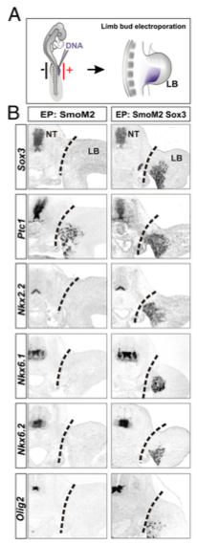
- Give a hypothesis as to the mechanism of how SHH and SoxB1 are activating gene expression.

Important signaling pathways

FGF→ FGFR → → Ets → activation of target gene expression

Shh→ → Smo → PKA → Gli → activation of target gene expression

BMP → → kinase → Smad → activation of target gene expression

Wnt → Fz ⊣ GSK ⊣ → activation of target gene expression

7. Some signaling pathways have instances of double repression within the pathway that leads to activation of target gene expression. How does this work?

