Dr. Helbock’s Lectures Review Sheet, Part I

Because he bounced around his worksheets, these review sheets will be a mix of all of his lectures. I will try to cover both worksheets.

Cardiac Abnormalities:

Atrioventricular Septal Defects

Schematic Drawing Anatomical Drawing

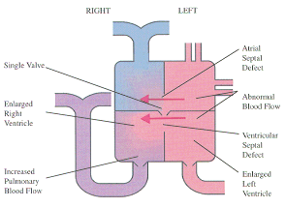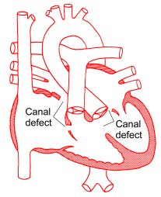

- What does the cardiac jelly form in the adult hear?
- Name some cardiac outflow abnormalities that Dr. Helbock talked about and what they have in common.
- In an adult, when a hypoxic state ensues, the heart both beats harder and increases its rate of beating. When a newborn (or fetus) is in a hypoxic state, the heart rate increases but contractility does not increase. Explain why this is.
- Describe the phenomenon of persistent pulmonary hypertension (PPHN).
- Why is it normal to see a deceleration and then acceleration of the fetal heart rate during delivery?

- The cardiac jelly, a part of the cardiac tube, develops into the cardiac cushion which develops into the valves of the heart. A defect in the development of the jelly to cushion to valves can result in congenital cardiac defects. This occurs because the cushion is the site of attachment of the valves to the cardiac tissue. If the attachment occurs too low, a congenital defect one would see is a large atria and small ventricles. Bad right? Because if not enough of blood is in the ventricle, then the heart cannot pump out enough blood to the body.
- The cardiac outflow anomalies Dr. Helbock talked about are all ventricular septal defects:
  - Tetralogy of Fallot – The pulmonary trunk is dysplastic (did not develop properly). It should be the same size as the aorta. This condition results from a single error: the conus septum develops too far anteriorly giving rise to two unequally proportioned vessels- - a large aorta and a smaller stenotic pulmonary trunk. The four main characteristics of Tetralogy of Fallot are:
    - pulmonary stenosis
    - ventricular septal defect (VSD) of the membranous portion (the septum is displaced too far anteriorly to contribute to the septum)
    - overriding aorta (the aorta straddles the VSD)
    - right ventricular hypertrophy due to the shunting of blood from left to right. (The pressure in the right ventricle is increased causing the walls of the right ventricle to expand.)

  - Transposition of great vessels: Transposition is a condition in which the aorta arises from the right ventricle and the pulmonary trunk from the left. This anomaly is due to the failure of the truncoconal swellings to grow in the normal spiral direction. There is also a ventricular septal defect and a patent ductus arteriosus. However, these secondary defects make life possible as they provide a way for oxygenated blood to reach the entire body.
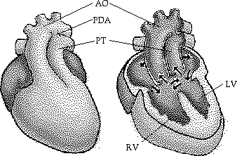

c. Patent Trunctus Arteriosus: A persistent truncus arteriosus results when the truncoconal swellings fail to grow. The single artery, the truncus arteriosus, arises from both ventricles above the ventricular septal defect, allowing pulmonary and systemic blood to mix. Distally, the single artery is divided into the aorta and pulmonary trunk by an incomplete septum.
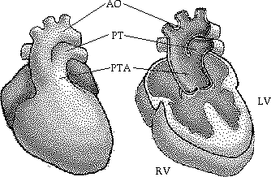
d. Double Outlet Right Ventricle: Aortic outflow from the right ventricle. With septal defect, no oxygenated blood would reach systemic circulation.

The reason that all of these cardiac abnormalities need a ventricular septal defect because if there is not mixing of right and left ventricular blood delivery of blood to the right place does not occur at all resulting in DEATH!!

- In the neonate, the myocardium is still developing and is functioning at its maximum capacity at all times. It cannot increase contractility because the muscles are not strong enough to do so. Because of this, the neonate can only increase heart rate in cases when hypoxic states threaten.

- Persistent pulmonary hypertension (PPHN) occurs after birth when the neonate is hypoxic. This occurs after the infant has taken a breath, cleared the fluid from the alveoli in the lungs, the ductus arteriosis closes because the pulmonary pressure decreases and systemic pressure increases begins lungs are now full of air. Unfortunately for some reason, some infants who enter hypoxic states (for any number of reasons) will revert back to fetal circulation by doing what they have done for nine months in utero. They constrict the pulmonary blood vessels, reducing blood flow to the lungs, the ductus arteriosis will open again. Why are they doing this? Because in utero, the lungs were way down on the fetus hierarchy of oxygenate blood. So they do what has been working for nine months when hypoxia occurs. Unfortunately, what they are doing is making their problem worse by cutting off blood to the oxygenation source. This would be like the fetus cutting off circulation to the umbilical vein – NOT GOOD!!

- By looking at the

Questions from the handout:
APGAR
Acclimitization how does it?
Core shell effect
