Exam 1 Key

Definitions:

1. Oviarole –**Rows of developing oocytes in ovary**

2. Tbx6- **transcriptional activator in Ciona**

3. Pole Cells- **germ cell progenitors in early fly embryo**

4. Proboscipedia. -**Labial-pb-dfd-sev-Antp. 2nd Hox gene in antennapedia complex**

5. Nanos -**localized inhibitor of maternal Hb translation in posterior regions of early fly embryo**.

6. Cactus- IKB. **Cytoplasmic inhibitor of Dorsal. Depleted by Toll signaling**

7. Ring canal- **Connection between germ cells in ovary due to incomplete cell division**

8. Kinesin- **motor protein at the + end of microtubules. Oskar transport**

9. Insulator. **DNA regulatory element that blocks enhancer promoter interactions**

10. Sox2 – **One of the ES cell determinants (w/ Nanog and Oct4)**

11. Bam **– Inhibitor of GSC proliferation repressed by BMP**

12. Swi/Snf.- **nucleosome remodeling enzyme that helps activate transcription**

13. Haltere- **vestigial wings in T3 mesothorax. Balance flight**.

14. Polar granules- **RNPs in posterior plasm lead to pole cells**

15. ICM – **inner cell mass. Small group of cells that form the entirety of mammalian embryo. Source of cells.**

1. Predict the phenotype of a mutant embryo lacking Polycomb, the entire BX-C, and Antp.

**Lab Pd Dfd Scr Antp Ubx AbdA AbdB**

**H1 H2 H3 T1 T2 T3 A1-4 A5-8**

**No posterior prevalence by Antp, Ubx, AbdA, or AbdB 🡪 Scr allowed to expand posteriorly**

**No Polycomb to prevent anterior boundary 🡪 Scr expands anteriorly, exerting posterior prevalence over the other remaining Hox genes**

**All segments take on T1 identity due to misexpression of Scr, the posterior-most remaining Hox gene in the ANT-C.**

**Careful:**

**Antp is mutant, not the entire ANT-C complex.**

1. A transcription factor called Smad is activated to form pSmad in response to Dpp signaling. Propose a model for the differential activation of gene expression in response to the Dpp signaling gradient in the dorsal ectoderm of the early Drosophila embryo.

**The extracellular Dpp gradient is converted to a gradient of nuclear, active pSmad (much the same way a Spz gradient is converted to a nuclear Dorsal gradient on the ventral side). pSmad levels are highest in the most dorsal tissue, and decrease progressively further away from that region.**

**Low-affinity pSmad binding sites in target gene enhancers can drive expression most dorsally, where pSmad is high (example: hindsight. This is most similar to Snail activation by high concentrations Dorsal).**

**High-affinity pSmad binding sites in other targets can drive expression less dorsally, even though there is less pSmad (example: pannier. This is most similar to rho activation by low concentrations of Dorsal).**

**Pictures ok too**

**Careful:**

**Dpp is not a transcription factor! Dpp is a secreted ligand that binds its receptors, causing them to dimerize and phosphorylate Smad (forming phospho-Smad, or “pSmad”). pSmad is now an activated transcription factor – this is the molecule that translocates into the nucleus and activates target genes by binding enhancers.**

**To reiterate:**

**The extracellular Dpp gradient is converted into a nuclear gradient of activated pSmad. Most dorsally, where pSmad accumulates in the nucleus at high levels, expression of target genes (e.g., hindsight) is driven by pSmad binding to low affinity sites. Progressively more ventrally, as pSmad levels decrease, expression of target genes (e.g., pannier) is driven by pSmad binding to high affinity sites.**

**Just as signaling activated by Spaetzle generates a nuclear Dorsal gradient in the ventral part of the embryo, signaling activated by Dpp generates a nuclear pSmad gradient in the dorsal part. Activation of target genes follows similar logic in each scenario (i.e. via the affinity threshold model).**

1. Predict the phenotype of a double mutant embryo lacking snail+ activity (sna-/sna-) and containing Toll10B, a constitutively activated form of Toll that is fully active in the absence of ligand.

**Constitutively active Toll is now acting on Cactus all over the embryo. Dorsal is thus free to enter every nucleus and drive target gene expression.**

**However, Snail is absent. Rho and Sog can be activated even by intermediate and low levels of Dorsal, so they are activated by the uniformly high levels now. Furthermore, Snail is not present to repress rho or Sog.**

**Because rho and Sog get expressed everywhere, they drive ventral neurogenic ectoderm identity throughout the embryo.**

**Not required: Sog inhibits Dpp signaling dorsally, inhibiting the dorsal ectodermal fate. But, points off if the answer only describes changes to mesoderm.**

**Careful: Dorsal is already expressed everywhere in the embryo. This manipulation causes it to now be active everywhere.**

1. Predict the phenotype of an adult fly that misexpresses Ubx+ in the wing primordium.

**Ubx is now expressed in T2 as well as T3. It acts normally to suppress wings and drive halteres in T3, but additionally inhibits Antp in T2 (posterior prevalence).**

**The fly has two pairs of halteres (one in T2 and on in T3) and no wings.**

**Careful:**

**“Misexpressed” indicates that Ubx is ectopically expressed in T2, but not that it’s missing from T3.**

**“Primordium” indicates that this misexpression happens early enough to have an effect on appendage fate.**

1. Transcription factor A is expressed in central regions of the early fly embryo, while factor B is expressed in the mesoderm. Propose the expression pattern and underlying mechanism for their synergistic activation of gene expression.

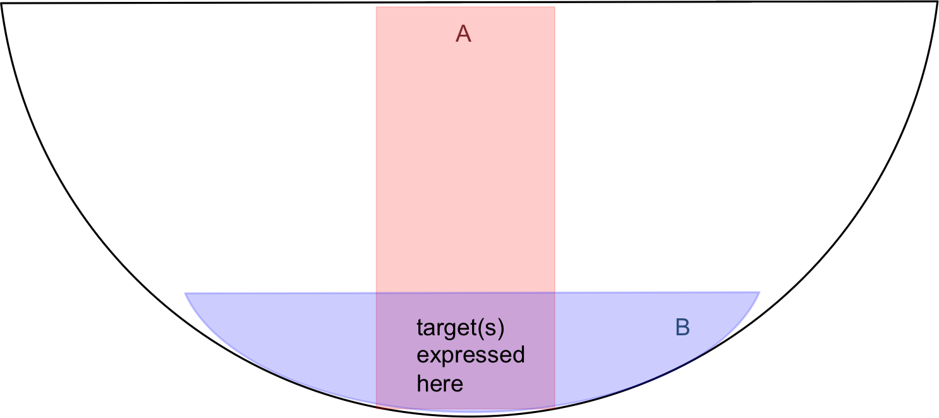

**Mechanism:**

**TF A binds an enhancer and recruits one coactivator (Swi/Snf, Mediator, HAT, etc.), which modifies DNA to allow TF B to bind more efficiently. TF B may recruit coactivators, too. The results is that the DNA is made more accessible to RNA pol II.**

**Partial credit for describing cooperativity of TF A and B binding. Full credit for describing coactivator recruitment.**

1. Predict the eve expression pattern in a mutant embryo containing a modified Kruppel protein that functions as a long-range repressor.

**Stripes 3 and 4 are lost. Kr bound to the nearby eve 2 and eve 5 enhancers can now repress eve3 and 4 enhancers, even though they’re far away on the chromosome. All other stripes (1, 2, 5, 6, 7) are expressed normally!!!!**

**Careful:**

**“Long-range repressor” means Kruppel bound to one enhancer can influence (repress) expression driven by another enhancer farther away *in the DNA*, not that Kruppel acts in an expanded area *of the embryo*.**

**In other words:**

**Do not confuse distance along the chromosome with distance along the embryo. The expression domain of Kr does not change – it can’t influence gene expression where it’s not present**

**(to reduce complexity, eve1 enhancer not shown)**





Problem sets:

1. A. Propose a scheme for altering the eve 3+7 enhancers so that is produces just a single stripe, stripe 7 rather than two stripes.

B. Propose a scheme for altering the eve stripe 2 enhancer so that is repressed in the ventral mesoderm and dorsal ectoderm, and thereby produce a patch of expression in the neurogenic ectoderm.

**A. Replace ubiquitous activator with Caudal activator or any other activator in the posterior half of the embryo.**

**B. Add Snail sites and Panier sites, assume Pannier sites (assume Pannier can act as a repressor)**

2. We discussed how Ubx, Antp, and abdA are sequentially activated across the anterior-posterior axis of the embryo. Propose a mechanism for the localized activation of AbdB.

**AbdB repressed by Hb + Kr + Kni. (partial credit for Hb + Kr + Giant).**

3. Consider an embryo derived from a mutant egg that lacks the normal gurken gene, but contains a modified gurken mRNA with the 3’ UTR from Oskar in place of the normal gurken UTR. Predict the changes in all relevant signaling activites and gene expression patterns.

**Gurken normally recruited to oocygte nucleus.**

**Oskar 3’ UTR relocalizes transcript to posterior pole.**

**EGF activated in posterior, turns off pipe in follicle cells.**

**Pipe on in anterior follicle cells leads to sulfonated ECM posterior.**

**Anterior to Posterior gradient of Toll signaling is created**

**Leads to Anterior to Posterior Dorsal nuclear gradient.**

**Snail is activated most anteriorly followed by Rhomboid, Sog and finally Dpp is expressed at the posterior.**